1. Total number unicorn companies

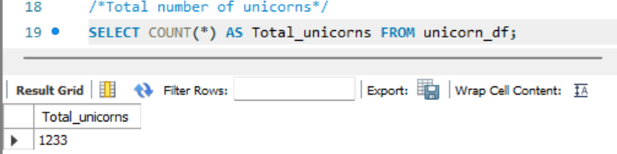

1. Total Valuation of All Unicorns (in Billion $)

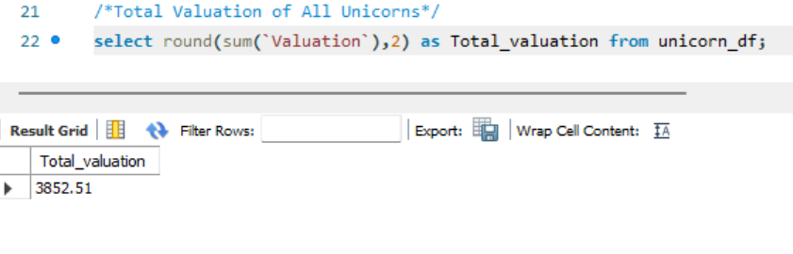

1. Average Valuation of a Unicorn (in Billion $)

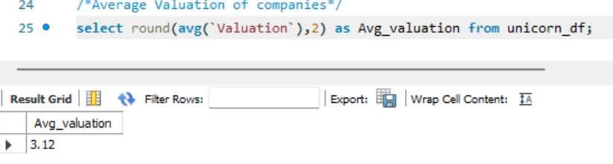

1. Most Valuable Unicorn Company

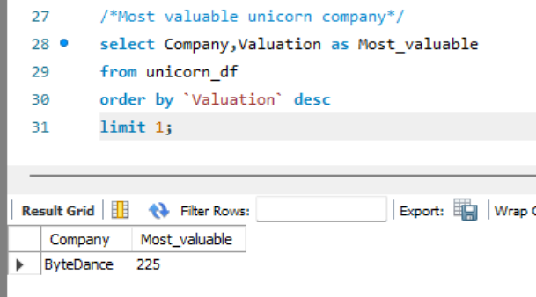

1. Country with the Most Unicorns

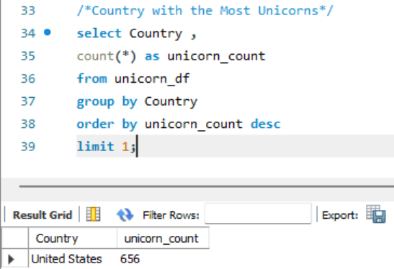

1. Industry with the Most Unicorns

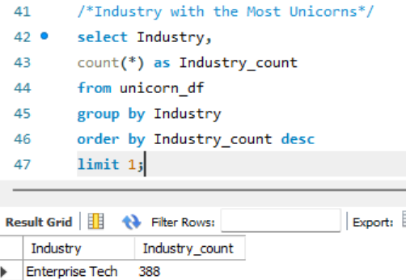

1. Year with the Highest Number of New Unicorns

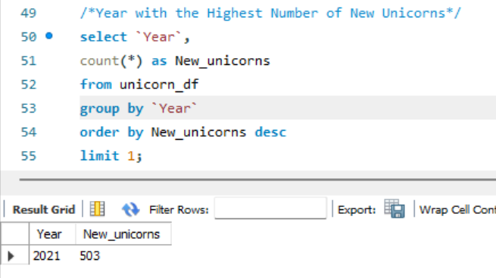

**Chart/Visuals**

1. Unicorn Count by Country (Top 10)

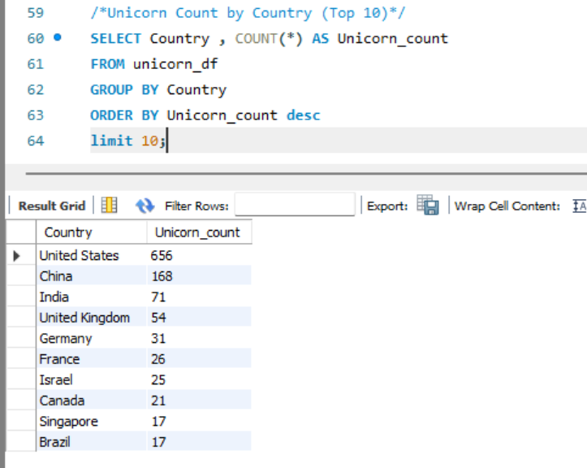

1. Unicorn Valuation by Industry

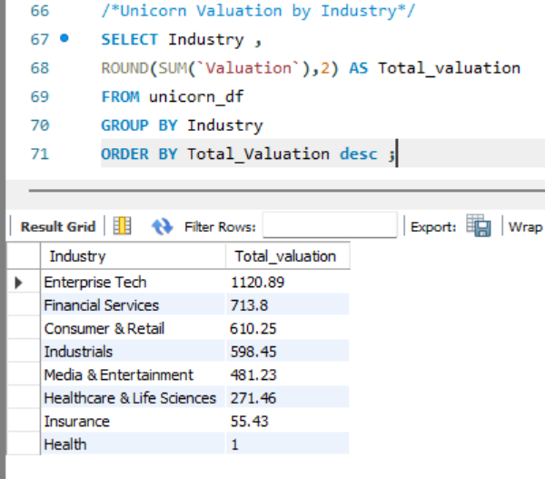

1. New Unicorns Over the Years

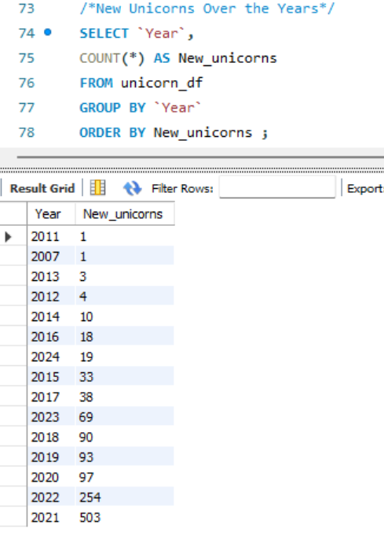

1. Monthly Trend of New Unicorns

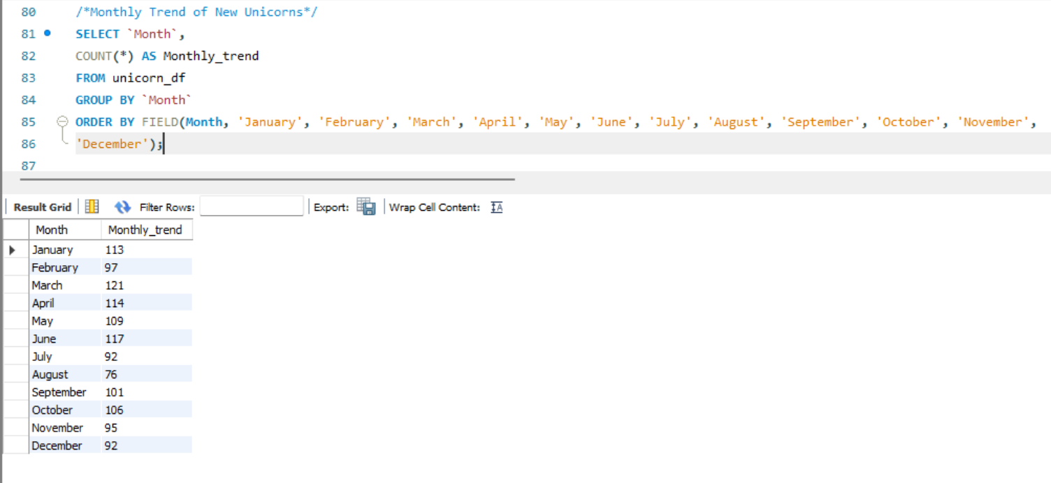

1. Top Cities with Most Unicorns

